EXPLANATION OF THE SIGNS IN THE DOCUMENT:

The parts of this document inwritten in blue are in the template for explanation only. They **must be deleted** or modified in the essay as follows!!!

**All texts in the essay must be written in black!!!**

<Personalize the text enclosed in <…> (relational symbols), everyone must enter their own data. Relational symbols must be deleted, leaving only the personalized content enclosed with them!>

{Text enclosed with {…} (parentheses) should be used if necessary. The parentheses must be deleted!}

**This document can be used as a template so please apply STYLES that are predefined in this temaplate (*Home / Styles*)**

**SCIENTIFIC STUDENTS’ ASSOCIATIONS CONFERENCE ESSAY**

**<STUDENT NAME>**

**<STUDENT NAME, if more…>**

**<YEAR>**

UNIVERSITY OF DUNAÚJVÁROS

**SCIENTIFIC STUDENTS’ ASSOCIATIONS CONFERENCE   
ESSAY**

***<****TITLE OF ESSAY****>***

|  |  |
| --- | --- |
| **Supervisor:** | **Student:** |
| <Supervisor Name> | <Student Name>  <Student Name, if more>  <Study Programme>  <year> |

Resume

The purpose of the abstract is to enable the student to summarize his / her dissertation in a concise way that is understandable to others. Another goal is to comply the essay with keeping the formal requirements and the logical structure, therefore an attention-grabbing text can be created at the same time. The recommended length of the abstract is half, but not more than one A4 page, where subheadings, literary references, and footnotes are prohibited.

The beginning of the abstract contains the suggestions and the goals. After this, the rest of the abstract contains an explanation of the applied methods, omitting the exact details, but highlighting the new results.

The abstract contains only the necessary and interesting information that reflects the dissertation properly. It is very important that new features, for example the development and optimization of a new method, are really emphasized.

Table of Content

1. Introduction 1

1.1. Aims and Objectives of Essay 1

1.2. Structure of Essay 1

2. Rules of Headings and Subheadings 2

2.1. Rules of References 2

2.1.1. Rules of Bibliography references in the text 2

2.1.2. Consequences of image references 3

2.1.1. Requirements for eference of tables 4

2.1.2. Requirements for reference of annexes 4

2.2. Source code in the text 5

3. Summary 6

Bibliography 7

List of Figures 8

List of Tables 9

List of annexes 10

Annex 1. Efficiency of combat nerve gases 11

# Introduction

The Candidate justifies the choice of topic, its theoretical and practical significance, formulates the objectives and research methods.

The Candidate describes the information related to the chosen topic, presents the goal set for his / her dissertation briefly. Describes the reasons why he / she chose this topic or task, why he / she considers it timely and important.

## The content and format requirements of TDK essay

The TDK essay must be prepared using a computer text editor as follows:

* **Formatting of body text:** Times New Roman font, font size 12, 1 cm first line indented, double-spaced, 3.0 cm margin on the left side, 2.5 cm margin on the right side, bottom and top.
* **Length:** The length of the main text (without the table of contents, bibliography, and appendices) must be at least 40,000 characters (minimum 25 pages), but papers longer than this can also be accepted (maximum 50 pages).…

## Structure of TDK essay

* table of contents
* introduction
* development of the main text and theme
* summary
* bibliography
* list of tables and figures (can be omitted in the absence of a sufficient number of tables and figures
* annexes (if necessary, individual annexes are marked with Roman numerals)

## Division of the TDK essay, page numbering

**The essay must be divided in a decimal system, if** possible at a maximum of three levels, in accordance with the table of contents. (The further breakdown of individual levels only makes sense if the breakdown results in at least two subsections at the lower level.)

In all cases, **the pages** must be numbered, in the center at the bottom of the page, with a decimal number. (Just a number, no period at the end!) The page number should start at chapter 1 (page 1), there is no page number in the preceding "Table of Contents".

# Rules of Headings and Subheadings

Each heading / title (Heading 1 style) start in new blank page.

The headings are followed by at least 1-2 paragraphs! Never include headings that are directly followed by a new, lower-level heading. Insert at least 1-2 paragraphs (through 2-3 lines each) of text bellow each heading. Furthermore, where a chapter has only one subchapter, the division of the subchapters is unnecessary. In this case, the whole content must be described within the chapter (without sub-chapter).

The main headings should be in the Heading 1 style, with the following settings: Times New Roman, 16pt, bold, centered, space before 0pt, space after 6pt, with decimal numbering, all Headline1 style lines should be placed on a new page (this setting is already included in the style itself).

## Rules of Sub-headings (level 2)

The sub-headings should be in Headline 2 style, with settings: Times New Roman, 14pt, bold, centered, space before 12pt, space after 6pt, with decimal numbering. Subheadings are only used if the given chapter can be divided into several subsections. If the chapter has only one subsection, it is unnecessary to divide the chapter into subsections. In such cases, the content must be described within the chapter.

### Rules of sub-sub-headings (level 3)

The sub-headings should be in Heading 2 style, with settings: Times New Roman, 12pt, bold, centered, space before 12pt, space after 6pt, with decimal numbering.

Sub-subheadings are used only if the given sub-chapter can be divided into several sub-sub-chapters. If the sub-chapter has only one sub-sub-chapter, further breakdown of the sub-chapter is unnecessary. In such a case, what has to be said must be described within the given subsection. A more detailed division than 3 levels is not good.

### Appearance of the titles of compulsory lists

The titles of the various lists should be as follows, in the Title line 1 style and without numbering in the document:

Table of contents (after cover and summary, before chapter 1. Introduction)

Bibliography (Summary after chapter, mandatory element)

List of figures (after bibliography, optional, if there are figures, then yes

List of tables (after the list of figures, optional, if there are tables, then yes)

List of attachments (after the list of tables, optional if there are any attachments)

## Rules of Bibliography References

Readers can get information of the depth of Candidate’s scientific work and research from the bibliography list at the end of the essay. References also prove that Candidate has avoided plagiarism and acknowledges his/her sources of information.

If Candidate makes non-literal reference from one specific scientific literature in case of one sentence, does so that in front of the punctuation mark at the end of the sentence, e.g.:

This is an example sentence to illustrate the reference type discussed above [1].

If a full paragraph is referenced from a piece of literature, put the reference number at the end of the paragraph, after the punctuation mark at the end of the sentence.

This is an example paragraph to illustrate the reference type discussed above. This is an example paragraph to illustrate the reference type discussed above. This is an example paragraph to illustrate the reference type discussed above. [1]

If there are more scientific sources of the paragraph(s), use references at the end of the text, divided them by . (comma) in case the references are in different part of the list of bibliography. In case they are after each other in the list, use references divided by – (hyphen). The following example shows the appropriate reference format for a sentence:

This is an example sentence to illustrate the link type discussed above [1-4], [5], [10].

The following example shows the appropriate reference format for one or more paragraphs:

This is an example paragraph to illustrate the more than one references type discussed above. This is an example paragraph to illustrate the reference type discussed above. This is an example paragraph to illustrate the reference type discussed above. [1-4], [5], [10]

In each case of literal quotation Candidate should enclose it in “ (quotation marks), align the quotation to the right and format italics, and place the reference at the end of the quotation. The dissertation can be continued in a new paragraph. For example:

*„*This is an example for a literal reference*.” [1]*

### Requirements for Reference of Images

The figures are placed in the dissertation according to Figure 1, as template provides, so **centered**, without indentation (!!!!) space before 18pt, line height is 1.5, with the appropriate resolution and size for easier readability.

Each figure must be followed by its fig. caption and must be a reference number (provided by *WORD References / Caption / Insert Caption*). Each fig. caption must be inserted as a reference and contains a fig. number and a title. The format of the fig. caption as template (TNR, 10pt, italic, centered, space before 0pt, after 18pt).

If Candidate uses/inserts a figure from outer source, the literature reference has to be inserted at the end of the fig. caption enclosed by […]. If Candidate uses self-edited figure, the fig. reference is the following text enclosed by (…): (self-edited figure). Candidate has to refer to each figure by its fig. number in the text, where it is mentioned, e.g. (Figure 1)!

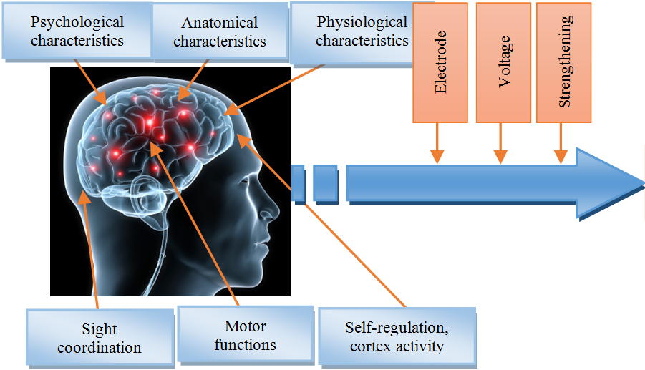

Figure 1: A simple model for processing bioelectrical signals [1]

Figures can also be inserted on the previous or next page, avoiding blank spaces at the bottom of the page. Do not place an image larger than 1/2 page! If it is justified to place the larger figure, then put it in "Appendix" and refer to it as an attachment in the text.

### Requirements for Reference of Tables

Just like figures, tables should be referenced in the text too (e.g. Table 1 shows the results of the research). Creating table captions with ref. number is like fig. caption (use Word references service). Table caption is centered with 1 normal style blank row before and after (or the better to use 12pt spacing before and after). Combine it with the appropriate colors for easier readability. The style in Table 1 example table is optional but recommended. If the table is broken by a page, do not leave it “cut in half”, use page break.

Table 1.: Results [1]

|  |  |  |  |  |  |
| --- | --- | --- | --- | --- | --- |
| **Course** | **Groups** | **Average** | **Deviation** | **Impact** | **t-test** |
| Mathematics | G1 | 3,036 | 0,769 | 0,14* | t = 0,53  (p < 0,05) |
| G2 | 3,15 | 0,933 |
| Electronics | G1 | 3,345 | 0,886 | 0,05* | t = 0,19  (p < 0,05) |
| G2 | 3,3 | 0,979 |
| Programming | G1 | 3,254 | 0,927 | 0,05* | t = 0,18  (p < 0,05) |
| G2 | 3,3 | 0,979 |

\**small impactg (d<0.5).*

Tables can be inserted on the previous or the next page to avoid large blanks.

### Requirements for Reference of Annexes

The appendices should be referred to in the text as with the figures and tables, e.g.: ”I have depicted the current state in the manner found in Appendix 1.”

## Source Code in the Text

Source code parts recommended to be display in the essay as text not as figures. Format them differently than body part (e.g. apply Consolas font type). Long codes (e.g. multi-page codes) have to be placed as appendices. In essay body Candidate should highlight the essential elements only. The most elegant way to represent the algorithm is to use language-independent description. Do not cut and insert the code-base written in a specific language into the essay body. Here are some samples bellow:

The following language-independent source code snippet contributed significantly to the optimization of the xy algorithm:

Algorithm arrayMax(A,n)

currentMax ← A[0]

for i ← 1 to n-1 do

if A[i] > currentMax then

currentMax ← A[i]

{ increment counter i }

return currentMax

The following C# source code snippet contributed significantly to the optimization of the xy algorithm:

int? currentMax = null;

int index = -1;

for (int i = 0; i < array.Length; i++)

{

int currentNum = array[i];

if (!currentMax.HasValue || currentNum > currentMax.Value)

{

currentMax = currentNum;

index = i;

}

}

# Summary

Candidate should summarize the essence of the TDK essay (essay) in this chapter, with a strong emphasis on his/her own results. Recommended size is up to 1 page.

# Bibliography

The scientific literature should be referred, therefore set its ref. number encloses by […]. In case of Internet sources the time of viewing must also be displayed. The required reference stye is IEEE (use Word bibliography references tool).

The following examples show different types of science literature. Essay recommended to contain at least 15-20 references, preferably of each type.

Journal article:

[1] J. Katona and A. Kovari, "A Brain–Computer Interface Project Applied in Computer Engineering," in *IEEE Transactions on Education*, vol. 59, no. 4, pp. 319-326, Nov. 2016.

Book:

[2] J. Sharp, *Microsoft Visual C# 2005 Step by Step.* Szak kiadó Kft., Bicske, 2005.

Book excerpt:

[3] J. Katona, T. Ujbanyi, G. Sziladi, A. Kovari: *Electroencephalogram-based brain-computer interface for Internet of Robotic Things*, Cognitive Infocommunications, theory and applications, Topics in Intelligent Engineering and Informatics, Springer, pp. 249-272, 2018.

Conference announcement:

[4] J. Katona, T. Ujbanyi, G. Sziladi and A. Kovari, "Speed control of Festo Robotino mobile robot using NeuroSky MindWave EEG headset based brain-computer interface," *2016 7th IEEE International Conference on Cognitive Infocommunications (CogInfoCom)*, Wroclaw, 2016, pp. 000251-000256.

Internet source:

[5] *EEG Headsets | NeuroSky Store*, Store.neurosky.com, 2017. [Online], Access: [https://store.neurosky.com](https://store.neurosky.com/) [Download: 2017. 07. 24.]

# List of Figures

Figure 1: A simple model for processing bioelectrical signals [1] 4

# List of Tables

Table 1.: Results [1] 4

# List of annexes

Annex 1.: Efficiency of combat nerve gases

# Annex 1. Efficiency of combat nerve gases

The appendices of the dissertation should be numbered if there are more of them. Candidate has to refer to the relevant Annex in the list of Annexes with a cross-reference.